**INTRODUCTION**

**Project overview:**

Importing and securing data in a Service Now project involves loading data from various sources into Service Now and then ensuring its security. This process typically uses import sets, transform maps, and various security measures to protect sensitive information.

**Purpose**

Importing and securing data in a Service Now project aims to efficiently and safely load data into the platform, ensuring data integrity and protecting sensitive information. This involves using import sets to bring data from various sources into Service Now, mapping it to target tables, and implementing security measures to control access and prevent unauthorized modifications.

**IDEATIONPHASE**

**Problem statement:**

Linking each record to an employee and pulling some employee details (like department ) into the record for easier reporting

**Challenges**:

Import data needs to be accurate and consistent across different sources

Different systems of in have different data structures and formats

**Objectives:**

Using service now's built in security features

Implementing data validation and cleansing

**REQUIREMENT ANALYSIS**

**Solution requirement (functional & Non functional)**

|  |  |
| --- | --- |
| Team ID | LTVIP2025TMID31005 |
| Project Name | Importing and securing Data in service now |

**Functional Requirements:**

following are the functional requirements of the proposed solution

|  |  |  |
| --- | --- | --- |
| **FR No** | **Functional requirements** | **Sub requirement** |
| FR-1 | Tables | Create table |
| FR-2 | Importing data | Importing data  Map fields |
| FR-3 | Using Dot walking to access employee department information | Dot walking |
| FR-4 | Access control list (ACL) | Creating an ACL |
| FR-5 | Roles | Create role update elevate role |
| FR-6 | Result | Testing result |

**Non functional requirements:**

Following are the non function requirements of the proposed solution

|  |  |  |
| --- | --- | --- |
| **NFR N0** | **Non functional requirement** | **Description** |
| NFR-1 | **Usability** | Answer the data import interface is user friendly |
| NFR-2 | **Security** | Define who can access modified or import data |
| NFR-3 | **Reliability** | Define how Data integrity will be maintained during import |
| NFR-4 | **Performance** | Define acceptable response times for data import process |
| NFR-5 | **Availability** | Implement comprehensive logging |
| NFR-6 | **Scalability** | And so the system can handle |

**Data flow diagram**

**Tables**

**Import data**

**Using dot walking to access employee department information**

**Access control list (ACL)**

**Roles**

**Result**

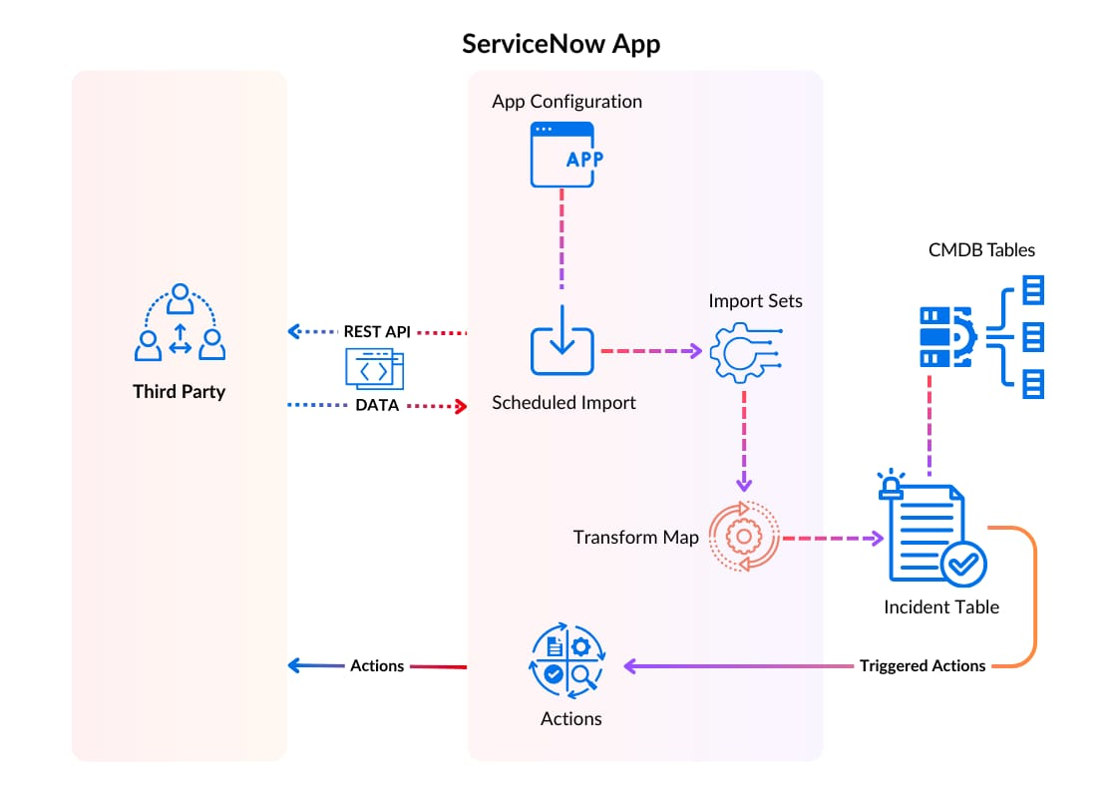**Technology stack**

Technology Stack:The image shows how data flows from a third-party system into the ServiceNow app, gets processed through import mechanisms, and ends up in the Incident Table, where it can trigger further actions or updates.

Third Party → REST API → ServiceNow

* Data is sent from a third-party system via REST API.

REST API → Scheduled Import

API data is captured by a scheduled import job.

Scheduled Import → Import Sets

* Data is loaded into temporary import tables.

Import Sets → Transform Map

* Data is transformed to match the format of the target tables.

Transform Map → Incident Table

* Transformed data is saved as incidents in ServiceNow.

Incident Table → Triggered Actions

* Actions (like alerts, updates) are automatically triggered.

Incident Table ↔ CMDB Tables

* Incidents are linked to Configuration Items (Cis) from the CMDB.

**PROJECT DESIGN**

**Proposed solution template**

Project team shall fill the following information in the proposal solution template

|  |  |  |
| --- | --- | --- |
| **S No** | **Parameters** | **Description** |
| 1. | Problem statement | Linking each record to an employee and pulling some employee details (like department ) into the record for easier reporting |
| 2. | Ideal / solution description | Multi step process using important maps for data loading combined with robot security measures to protect sensitive information |
| 3. | Novelty / uniqueness | Ensure should Data integrity and confidently during the import process and within the platform |
| 4. | Social impact / customer satisfaction | Ensure that I is handled and securely leading to increase customer satisfaction and positive social impact |
| 5. | Business model (revenue model) | Customer pay for the right to use service now and that includes the ability to import data from various source |
| 6. | Scalability of the solution | Service now can handle growing that of volumes and maintain Data integrity and confidently |

**Milestone 1: tables**

**Steps:**

1. Open service now
2. Click on all > >search for tables
3. Select tables under system security
4. Click on new
5. 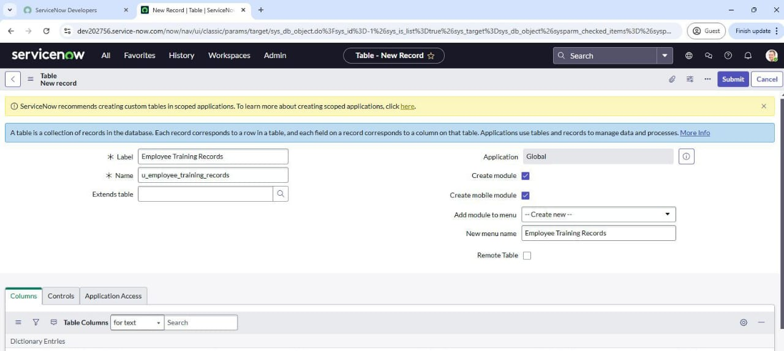Fill the following details to create a new table
6. Add the following fields:
7. Training name (type: string)
8. Completion date (type: date)
9. Status (type: choice)
10. Employee( type: reference),(reference field to system user table)

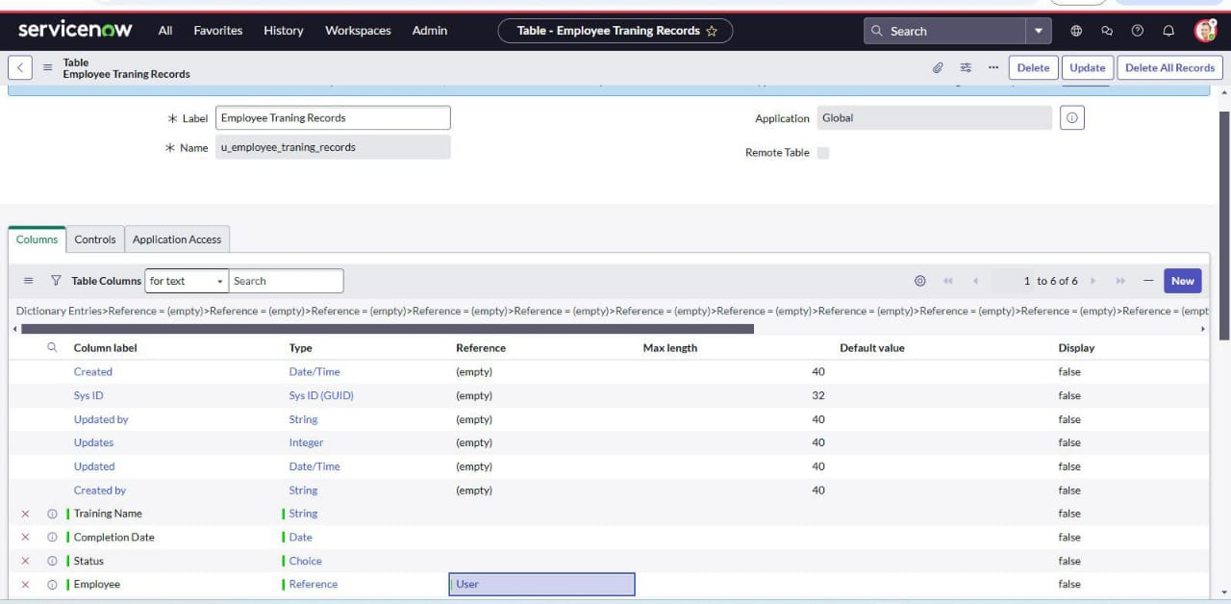

1. Click on submit
2. Click on choice and add to choices in the dictionary entry status

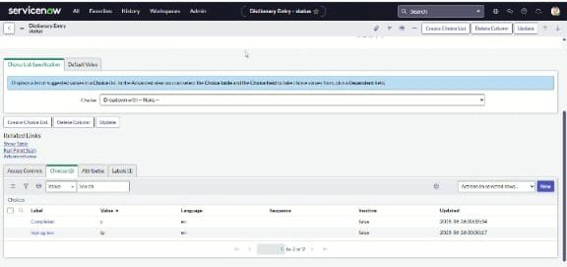

**Milestone 2: import data**

**Steps**

1. Open service now
2. Click on all > >search for system import s Select
3. Select load data and upload file that you have already created with four fields that are: (training name, completion date, status and employee)
4. Label: employee training
5. Name: u_employee_training

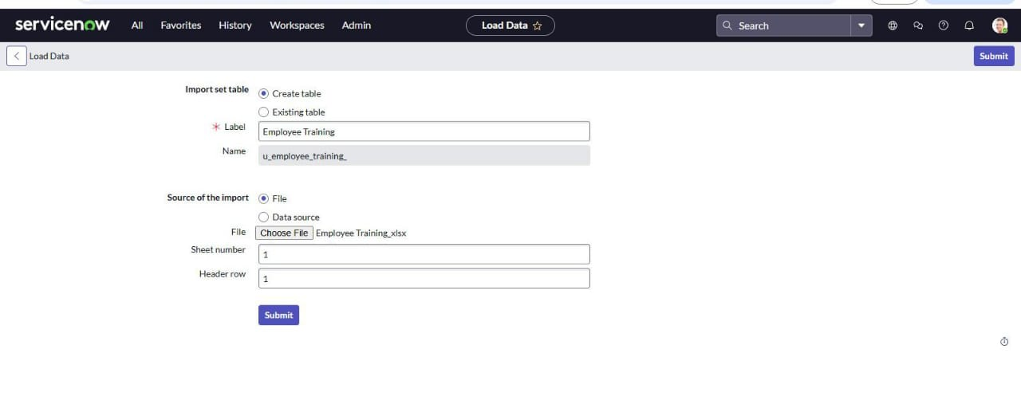

1. Click on submit

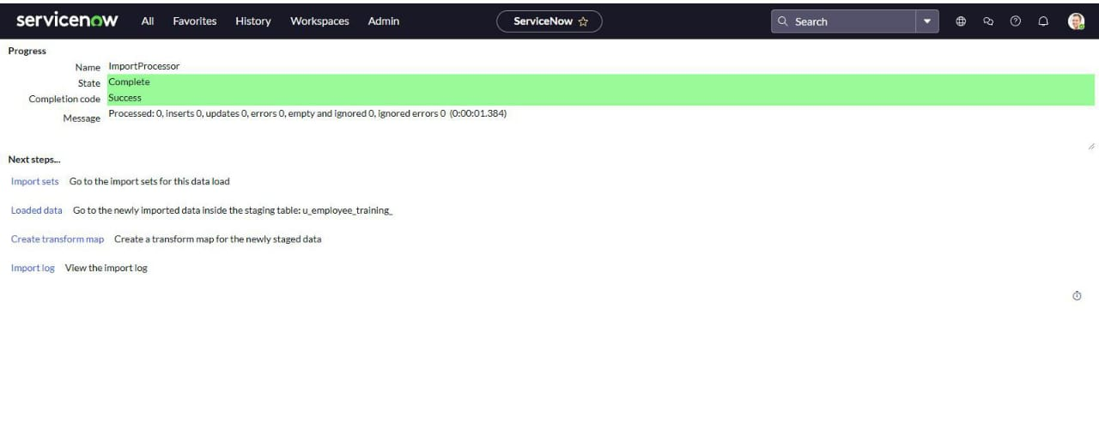**Map fields**

**Steps:**

1. Open service now
2. Click on all > > search for Transform maps
3. Fill the following details to create a new table
4. 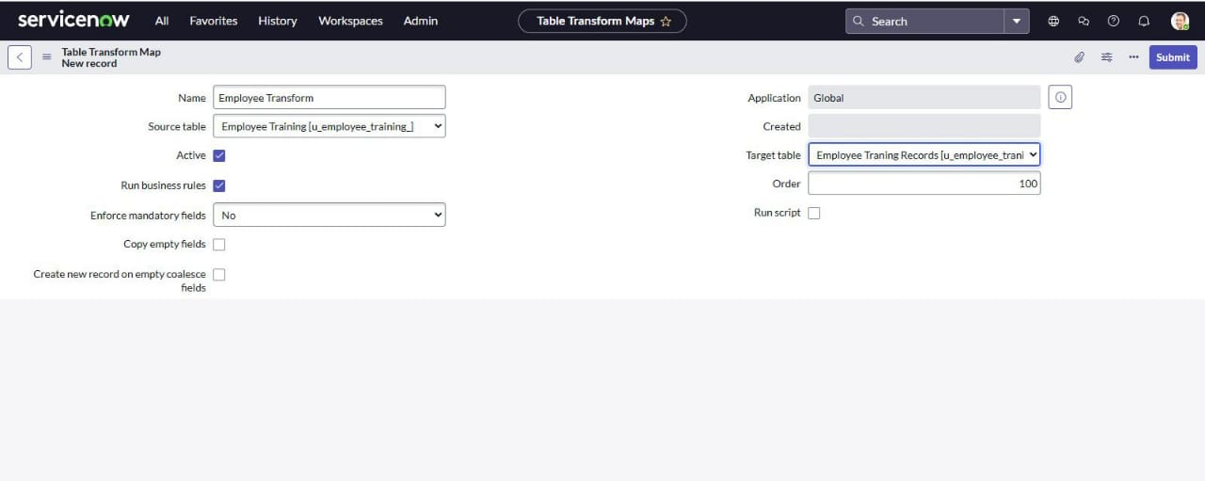 Click on submit

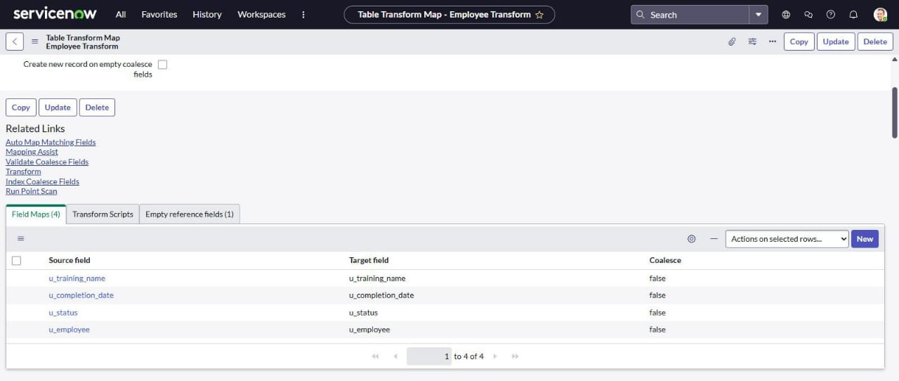

1. Add field maps as shown
2. Click transform to run the import

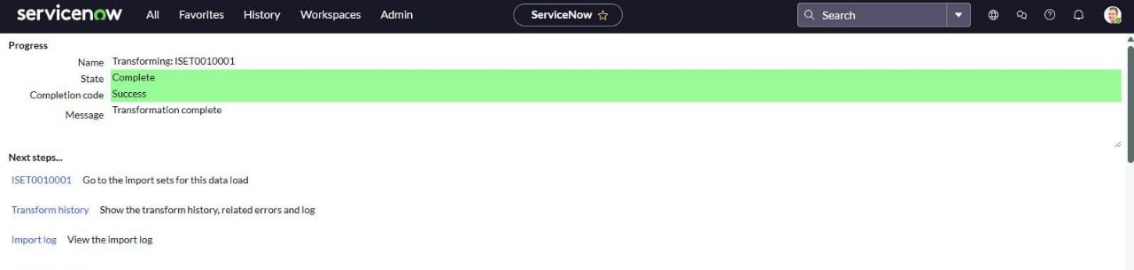

**Milestone 3: using dot walking to access employee department information**

**Steps:**

1. Open service now
2. Click on all >> system definition >>list layouts
3. Search for customer orders
4. Add the employee department field by using dot walking
5. Select the field and save changes

**Milestone 4: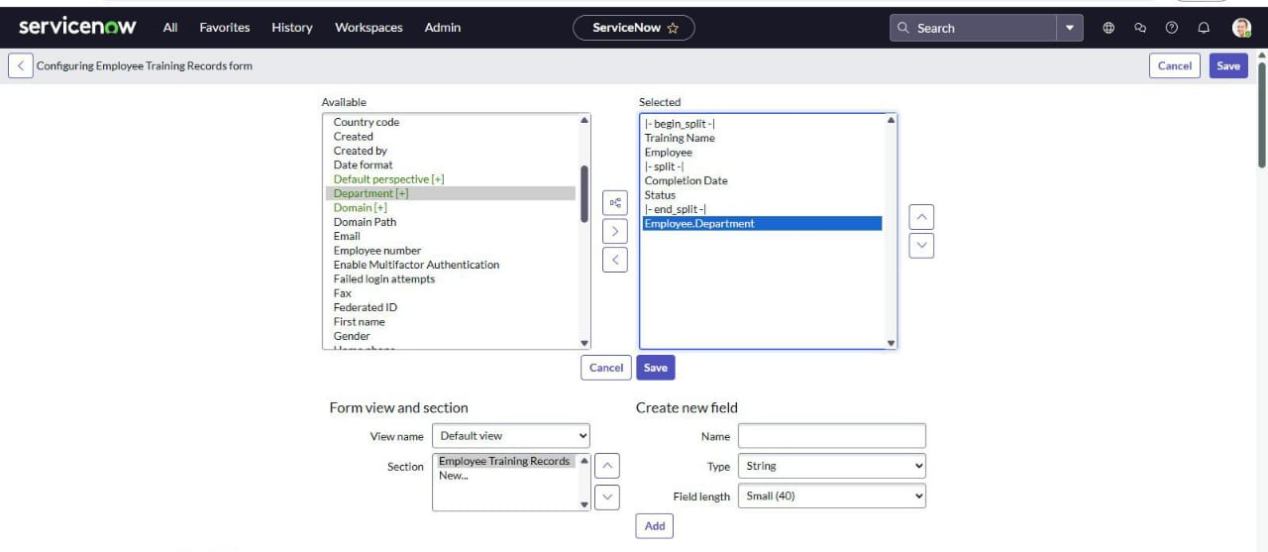Access control list (ACL)**

**Steps:**

1. Open service now
2. Click on all>>ACL>>create new ACL
3. Define ACL (Employees)
4. Operation: Read

**Milestone 5: Roles**

**Steps:**

1. Open service now
2. Click on all>>roles>>create a new role:Hr manager
3. Add in the sys_user

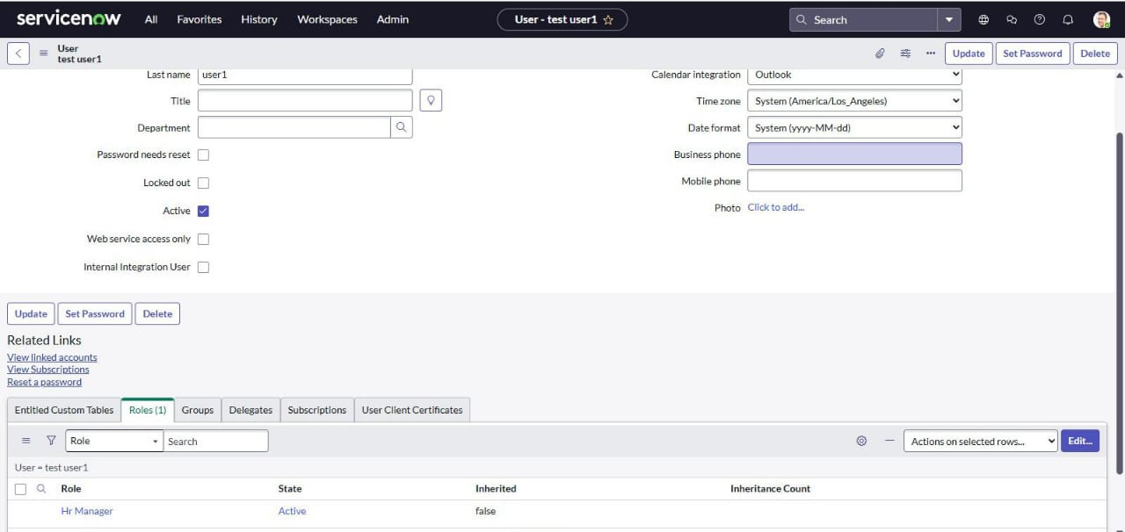

1. Add this roll to the tables application and module

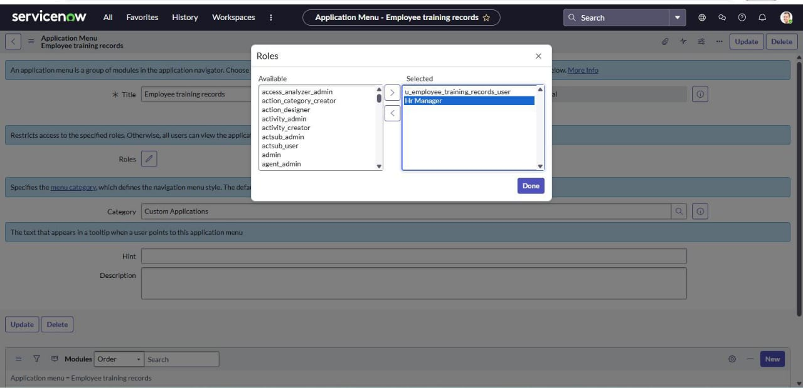

1. At the HR manager role to the sys_user

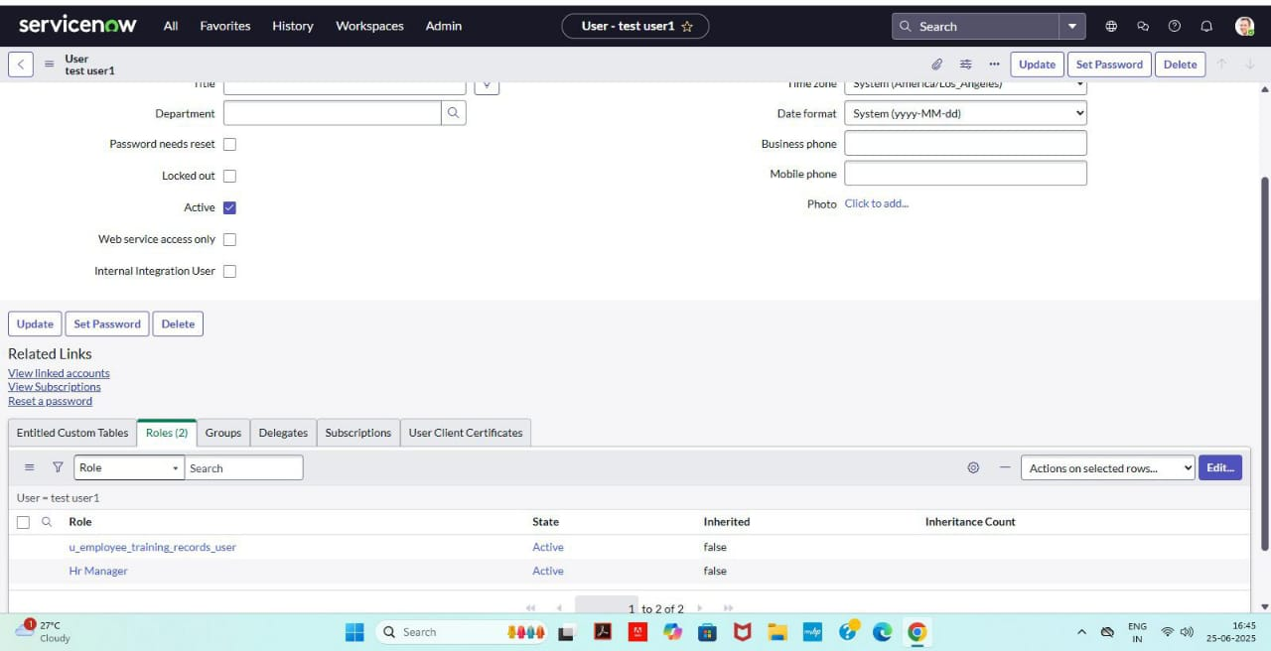

1. 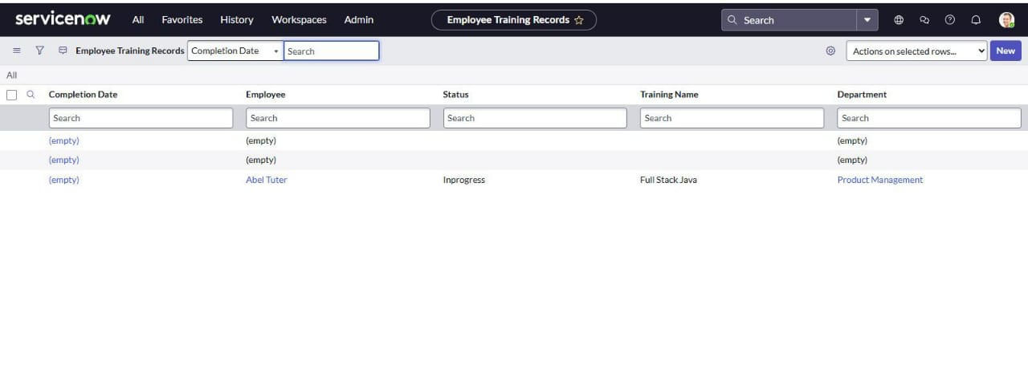Now you can view each employees department information directly in the employee training records list view

**Update to elevate role**

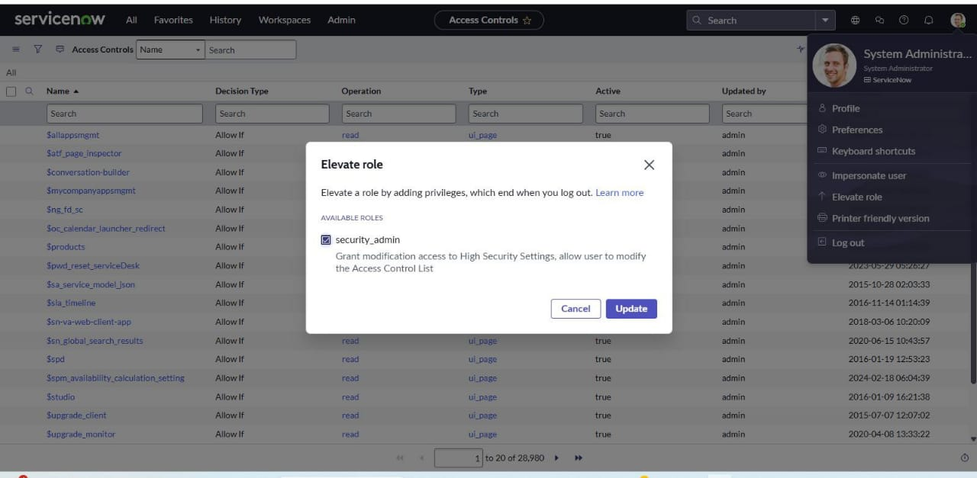**Steps:**

1. 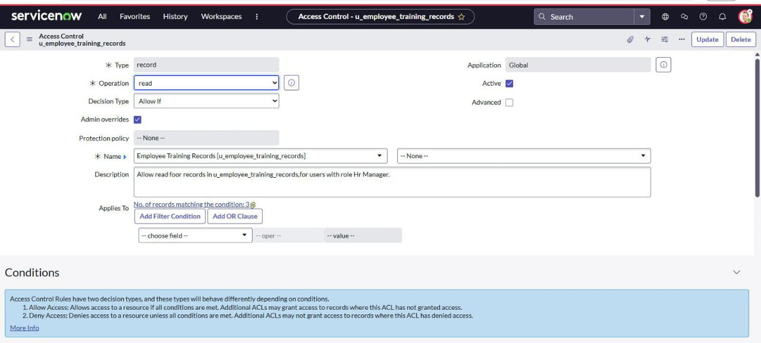Create new ACL and give read access to employee training records table
2. Give HR manager role to the ACL

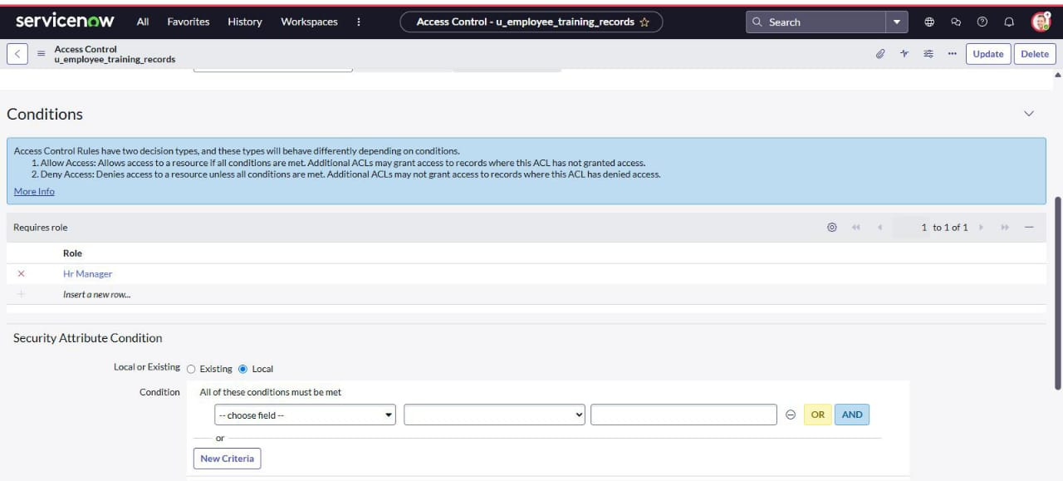

1. 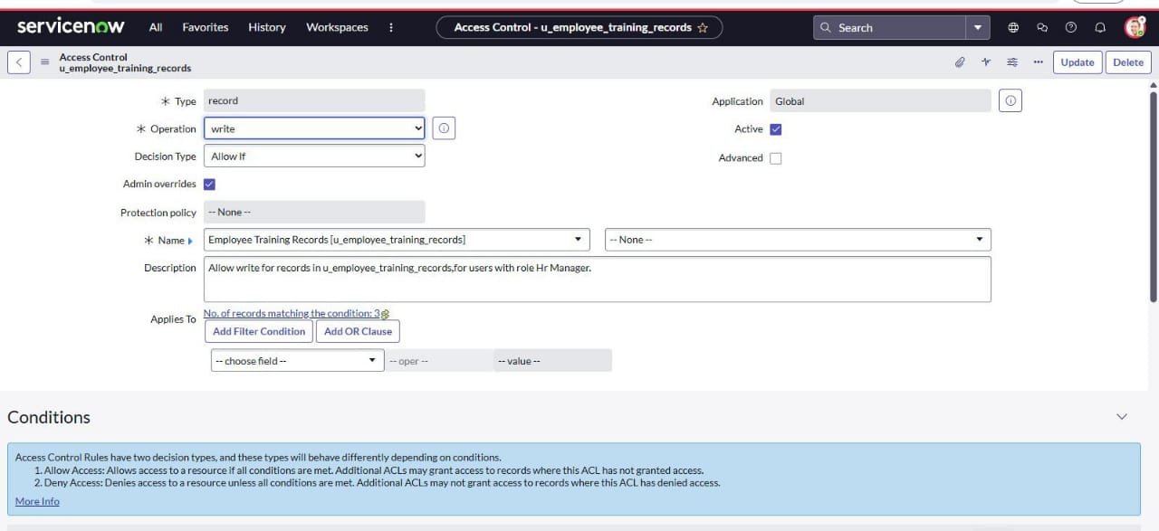Create another new ACL and repeat the same process to the write access

**Milestone 6: result**

**Steps :**

1. Impersonate the sys_ user and search employee training records
2. Now you can see and edit the fields

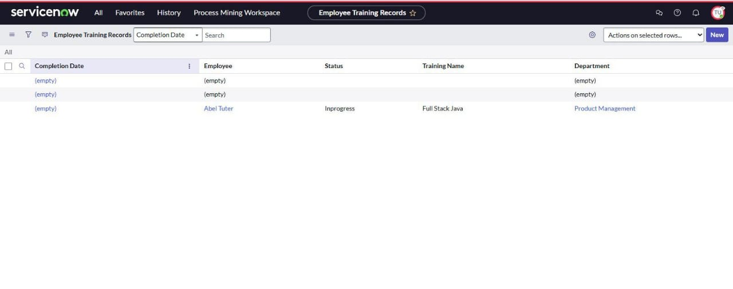

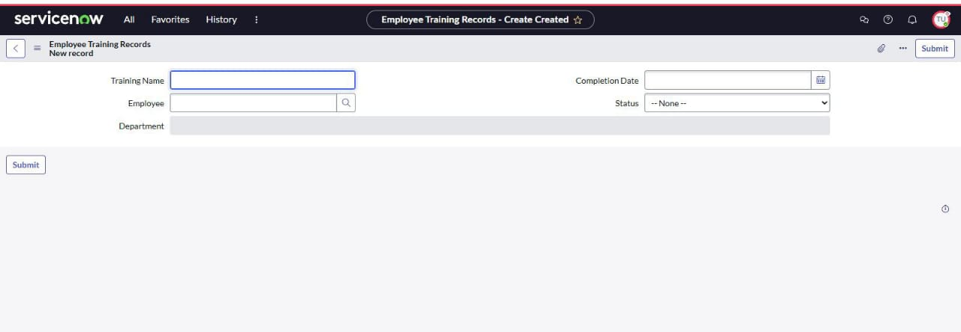

1. Impersonate the other user you cannot see the table

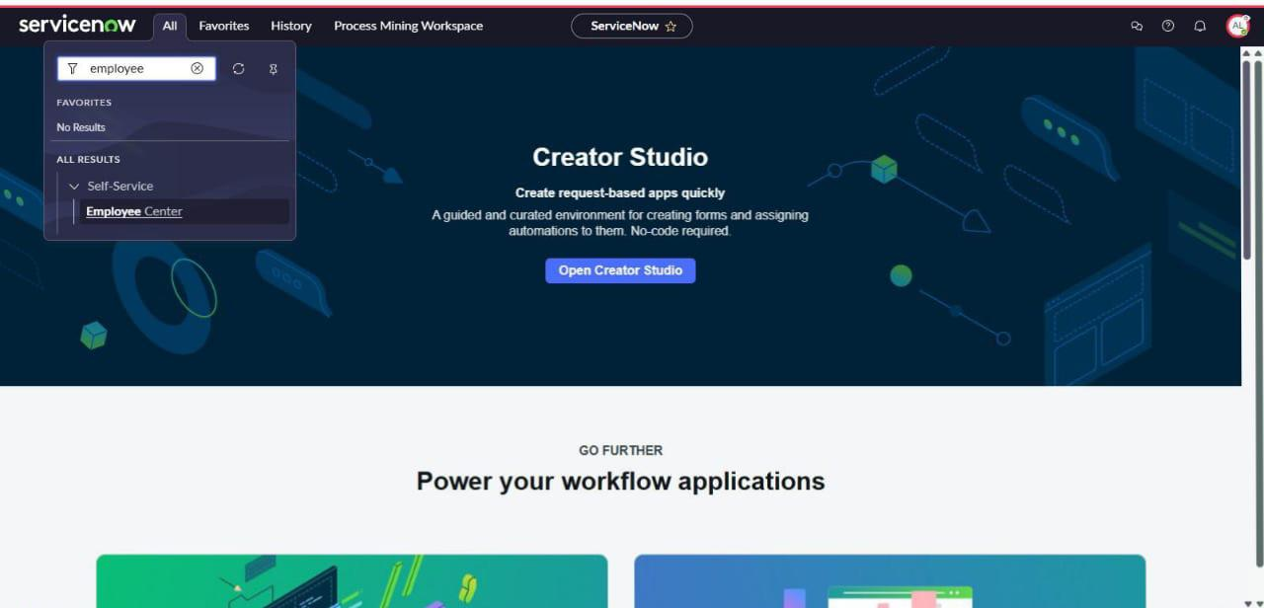

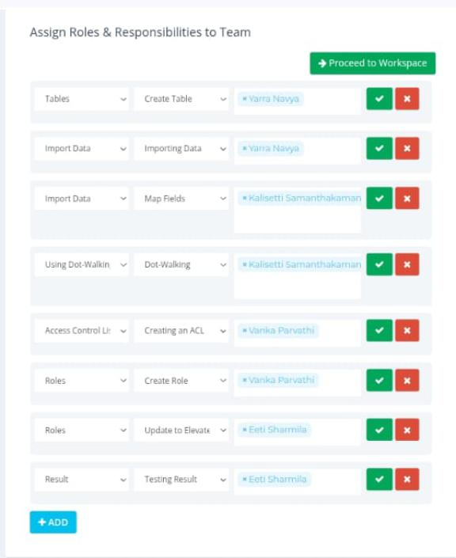 **PROJECT PLANNING AND SCHEDULING**

|  |  |  |  |
| --- | --- | --- | --- |
| **Functional requirements** | **User story** | **No of activity** | **Team members** |
| Tables | Create table | 1 | Yarra Navya |
| Import data | Importing data | 1 | Yarra Navya |
| Import data | Map filelds | 1 | Kalisetti Samanthakamani |
| Using dot walking to access employee department | Dot walking | 1 | Kalisetti Samanthakamani |
| Access control list (ACL) | Creating an ACL | 1 | Vanka Parvathi |
| Roles | Create role | 1 | Vanka Parvathi |
| Roles | Update to elevate role | 1 | Eeti Sharmila |
| Result | Testing result | 1 | Eeti Sharmila |

**FUNCTIONAL AND PERFORMANCE TESTING**

**Performance testing**

**Milestone 6: result**

1. Impersonate the sys_ user and search employee training records
2. 2.Now you can see and edit the fields



3.Impersonate the other user you cannot see the table

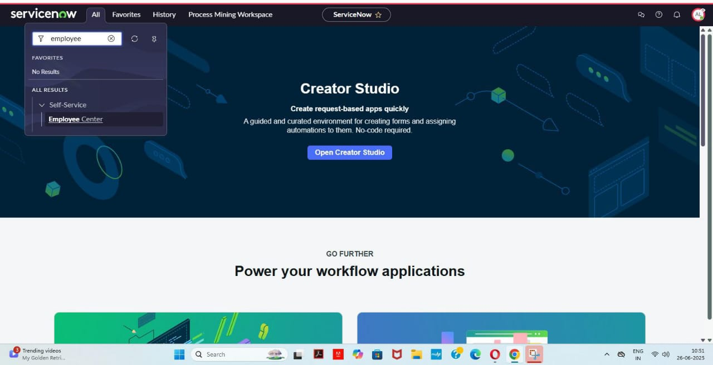

**ADVANTAGES & DISADVANTAGES**

**Advantages**

* Ensures accurate data import and reduces errors.
* Protects sensitive data from unauthorized access.
* Helps meet regulatory requirements and industry standards.
* Maintains data consistency and completeness.
* Streamlines data import and management processes.
* Minimizes risks associated with data breaches or unauthorized access.

**Disadvantages**

* Importing and securing data can be a complex process, requiring specialized knowledge and expertise.
* The process can be time-consuming, especially for large datasets or complex security configuration.
* Importing and securing data may require significant resources, including personnel, infrastructure, and technology.
* Errors during the import process can lead to data inconsistencies or security vulnerabilities.
* Implementing robust security measures and importing data can incur additional costs, such as licensing fees or consulting services.

**CONCLUSION:**

The **importing and securing Data in service now project** demonstrated the essential process of importing data into Service Now using Import Sets, leveraging dot-walking to access and utilize related table data efficiently, and applying Access Control Rules (ACLs) to enforce robust data security. By combining these core functionalities, we ensured accurate data integration, streamlined data relationships, and protected sensitive information through role-based access control.